REAL-TIME ATOMIZATION OF AGRICULTURAL ENVIRONMENT FOR SOCIAL MODERNIZATION OF INDIAN AGRICULTURAL SYSTEM
Abstract: -

Internet Of Things (IoT)is a shared network of objects or things which can interact with each other provided the Internet connection. IoT plays an important role in agriculture industry which can feed 9.6 billion people on the Earth by 2050. Smart Agriculture helps to reduce wastage, effective usage of fertilizer and thereby increase the crop yield. In this work, a system is developed to monitor crop-field using sensors (soil moisture, temperature, humidity, Light) and automate the irrigation system. The data from sensors are sent to Web server database using wifi modules ..

Introduction

In this system raspberry pi is used to control and motor the plantation The irrigation is automated if the moisture and temperature of the field falls below the brink. If any one animals are entered inside the field it detect and take photo graph and send to our mail control can also be automated in addition to irrigation. The notifications are sent to farmers' mail periodically. The farmers' can able to monitor the field conditions from anywhere. This system will be more useful in areas where water is in scarce. This system is 92% more efficient than the conventional approach .The Raspberry Pi is a low cost, c redit-card sized computer that plugs into a computer monitor or TV, and uses a standard keyboard and mouse. It is a capable little device that enables people of all ages to explore computing, and to learn how to program in languages like Scratch and Python. It’s capable of doing everything you’d expect a desktop computer to do, from browsing the internet and playing high-definition video, to making spreadsheets, word-processing, and playing games.
What’s more, the Raspberry Pi has the ability to interact with the outside world, and has been used in a wide array of digital maker projects, from music machines and parent detectors to weather stations and tweeting birdhouses with infra-red cameras. We want to see the Raspberry Pi being used by kids all over the world to learn to program and understand how computers work. Dimensions: 85mm x 56mm x 17mm

BLOCK DIAGRAM

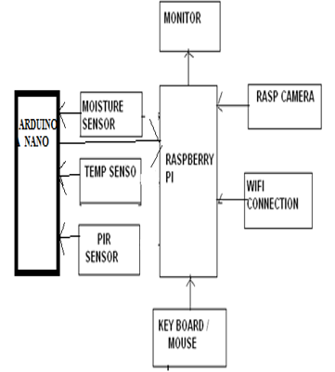

Hardware and software requirement

1. Raspberry Pi
2. pir sensor
3. moisture sensor
4. temperature sensor
5. Rasp camera
6. wifi module

Software- python

